Heart & Stroke Foundation of Canada CPR  WHEN  Sat., Sept. 8, 2018  9:00 or 1:00  WHERE  Pinewood Lodge  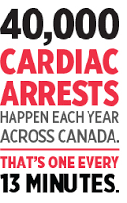 |  |  |  | Courses  compliments of the  Kevin Howie Memorial Search and  Rescue Fund  Thank you to Pinewood lodge for graciously hosting this training.  Please register early as space is limited  To register for one of these free courses call (204)348-7041  